YEAR 10 RIGHTS & FREEDOMS
Indigenous rights and freedoms assignment

Description of activity: What you need to do?
You are to write a letter of 300-600 words (using MS Word, Pages
or other such application), to the editor of a newspaper on one of
the following ways that Aboriginal people suffered from 1920-1960:
- the Stolen Generations,
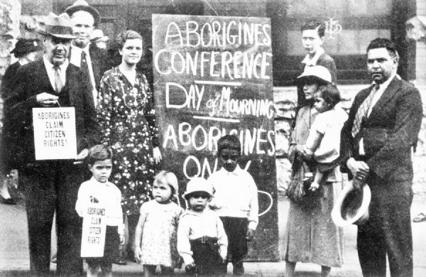
- Freedom Rides,
- Assimilation policies
- Native title and land rights
- William Cooper

The letter you write is to be based on a range of sources selected from individual research and must address the following:

• how and why Aboriginal people have been affected
• government policy towards Aboriginal people between the years 1920-1960
• experiences of Aboriginal people,
• the impact of these policies on members of the Aboriginal community
based on a specific case study.

Context: why are you doing this?
This activity involves an investigation of the experiences of the
Stolen Generations. In the Rights & Freedoms unit, students
have examined changes in government policies towards Aboriginal
peoples, including protection, land rights, and forced assimilation.

Criteria: How will you know if you’ve been successful?
Tick them off as you go.
 | High | Medium | Low | NA
Explain the government policies towards Aboriginal people before 1967
Demonstrate an understanding of the varying
experiences of the Aboriginal people
Select relevant information about these events from different sources
Use relevant historical terms and concepts appropriately
Communicate in a well-structured letter to the editor an argument supported by relevant historical evidence
Research relevant historical information from a variety of
sources
Explain how reconciliation is essential to
understanding the changing rights and freedoms of
Aboriginal peoples.

